RL Heart: Markov decision process
- Environments - reward, agent, actions, observations
- Agent Level - state, episode, history, value, gain
MDP is like Russian matryoshka doll
- Markov process {MP} – Markov chain
- Markov reward process {MRP} – MP + reward
- Markov decision process {MDP} – MRP + actions
MARKOV CHAIN/MARKOV PROCESS:
- observe state
- state space – switch states
- state space data = history
- e.g. [sunny, sunny, rain, sunny….]
we can add more dependencies:
state space: [sunny + summer, sunny + winter, rainy + summer, rainy + winter]
e.g. parameters: [weather, season, Lat-long, Country… so on]
but transition matrix = N x N is no. of states
for example: office worker
- Home
- Computer
- Coffee
- Chat
Transition matrix:
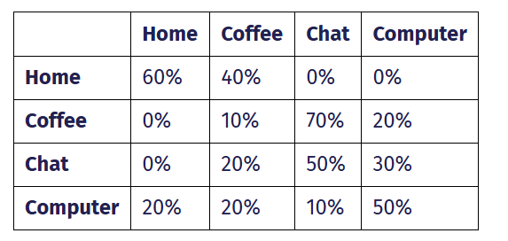
We make episodes
- Home → Coffee → Coffee → Chat → Chat → Coffee → Computer → Computer → Home
- Computer → Computer → Chat → Chat → Coffee → Computer → Computer → Computer
- Home → Home → Coffee → Chat → Computer → Coffee → Coffee

Markov property is stationary:
- Observation Transition distribution of states not change over time
MARKOV REWARD PROCESS
We can add another matrix state. For example, transition matrix (I, J)
To calculate reward, we add discount factor Y basically [0 – 1]
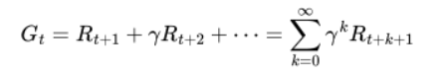
For example: Dilbert reward process
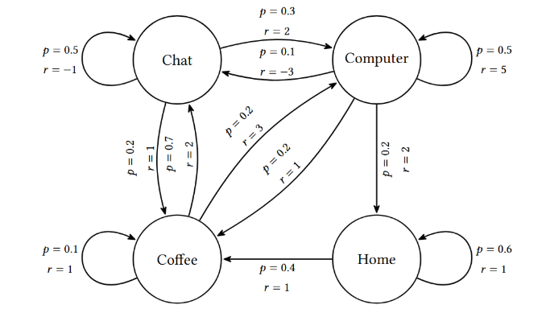
We calculate the probabilities with Y = 0:
V (chat) = − 1 ⋅ 0.5 + 2 ⋅ 0.3 + 1 ⋅ 0.2 = 0.3
V (coffee) = 2 ⋅ 0.7 + 1 ⋅ 0.1 + 3 ⋅ 0.2 = 2.1
V (home) = 1 ⋅ 0.6 + 1 ⋅ 0.4 = 1.0
V (computer) = 5 ⋅ 0.5 + (− 3) ⋅ 0.1 + 1 ⋅ 0.2 + 2 ⋅ 0.2 = 2.8

Therefore computer computer is best
If Y = 1 then infinite for all state.
Note: for short states: like [tic-toc game] we can use Y = 1 {mostly nine steps states}

Best Algorithm for example is: Q-learning method

MARKOV DECISION PROCESS:
Similar to MRP, add Depth in transition matrix (I, J, K)
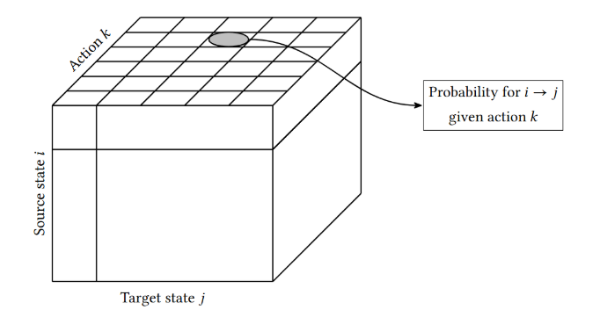
we have an agent (ARM) which can take actions, not like observe state transitions.
effect probabilities of target state which is useful in RL.
- To capture agent’s reaction on environments we have 3D matrix
- Source state, action, target state
- For most effective transitions, we need Policy

Agent’s actions are defined by Policy we make.
Robot grid world policy.
- Blindly move forward
- Try obstacles check previous forward action fail
- Spin around for entertainment
- Choose action randomly like drunken robot
Main goal for agent is return +ve results.

There are different policy’s
- Deterministic policy
- Stochastic policy
- Random policy

